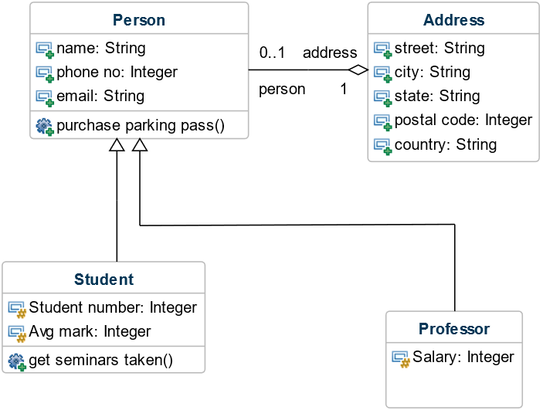

2))
int i = 10;
while (i <= 50) {

System.out.print(i);
i = i + 10;
}
System.out.println("__________");
int j = 3;
while (j >= 0) {

System.out.print(j * 3);
j = j - 1;
}
System.out.println("__________");

int x = 1;
while (x <= 4) {
System.out.print(x * x);
x++;
}
System.out.println("__________");
}
}

Output:
run:
1020304050__________
9630__________
14916__________
BUILD SUCCESSFUL (total time: 0 seconds)

3)))
int i;
for (i = 60; i >= 10; i = i - 10) {
System.out.print(i);
}
System.out.println("*****");
int j;
for (j = 1; j <= 5; j = j + 1) {
System.out.print(j * j);
}
System.out.println("*****");
int k;
for (k = 4; k >= 1; k--) {
System.out.print(k * k * k);
}
}
}
run:
605040302010*****
1491625*****
642781BUILD SUCCESSFUL (total time: 0 seconds)

4))
public class Salary {
int hours;
int rate;
public static void main(String[] args) {
int s=findSalary(10,12);
System.out.println("SALARY =" +s);
}
public static int findSalary(int hours,int rate){

int salary = hours*rate;
return salary;
}
}
run:
SALARY =120
BUILD SUCCESSFUL (total time: 0 seconds)
5))
public static void main(String[] args) {
// TODO code application logic here
String grade = calcGrade(90, 90, 95);
System.out.println("Grade = " + grade);
String grade1 = calcGrade(70, 80, 95);
System.out.println("Grade = " + grade1);
String grade2 = calcGrade(60, 50, 25);
System.out.println("Grade = " + grade2);

}
static String calcGrade(int eng, int sci, int math) {
int total = eng + sci + math;
int avg = total / 3;
if (avg < 60) {
return "F";
} else if (avg < 70) {
return "D";
} else if (avg < 80) {
return "C";
} else if (avg < 90) {
return "B";
} else {
return "A";

}

}
}
run:
Grade = A
Grade = B
Grade = F
7)))
for (int i = 1; i <= 10; i++) {
for (int j = 1; j <= i; j++) {
System.out.print("*");
}
System.out.println("");

**
***
****
*****
******
*******
********
*********
**********
BUILD SUCCESSFUL (total time: 0 seconds)
8)))
for (int i = 1; i <= 10; i++) {
for (int j = 10; j >= i; j--) {
System.out.print("*");
}
System.out.println("");
run:
**********
*********
********
*******
******
*****
****
***
**
*

